Iteration 2 Implementation and Testing

Michael Lee

Russell Whaley

COMP3700

1. **As a user, I want to log into the system. The login page is shown.**

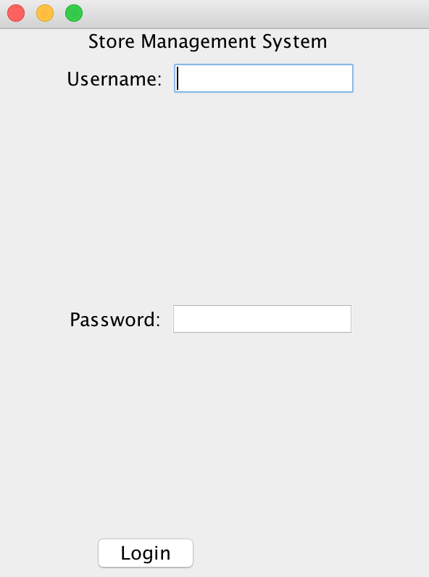

The user enters their username and password and clicks “Login”. The home page comes up.

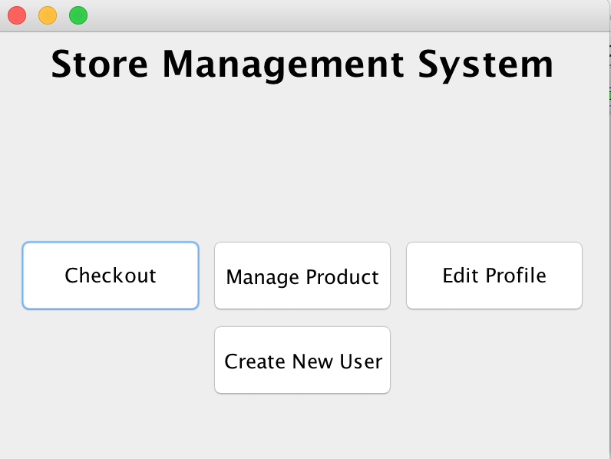

**2. As a user, I want to change my login password.** Repeat use case 1. Select The edit profile option in the home screen. The edit profile page comes up.

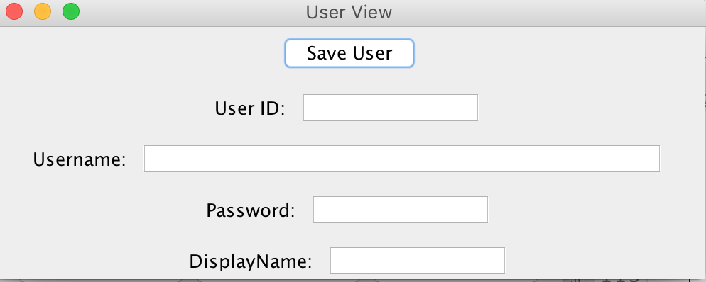

To update password, the user must provide their userID in the first text box. Then type in a new password in the password text box and press “Save User” to update it in the database.

Database before and after:

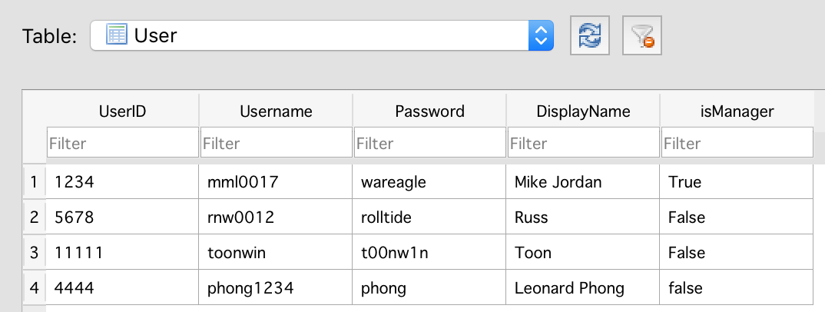

Updating password of rnw0012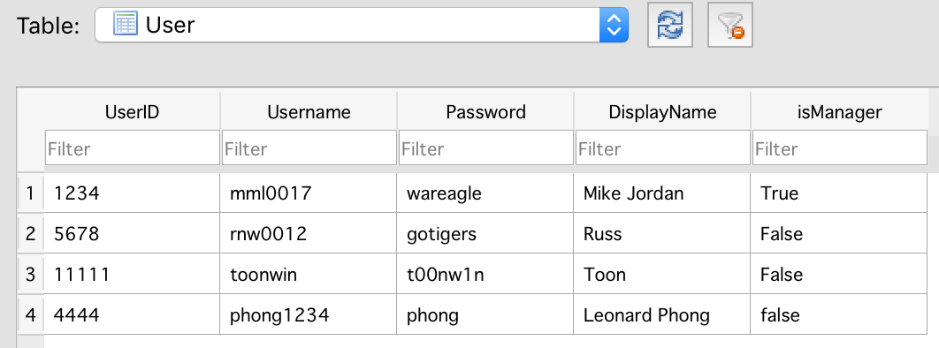

**3. As a user, I want to change my profile photo.** The user does use case 1. The home page comes up.



The user selects the edit profile button. The edit profile screen comes up.



The user selects the update picture option. The update picture screen comes up.

The user enters the location and name of the file that is the picture they want to upload. The user is returned to the home screen with their picture updated.

**4. As a cashier, I want to checkout an order.** The user repeats use case 1. The home screen appears.



The user selects the checkout option. The checkout screen appears.

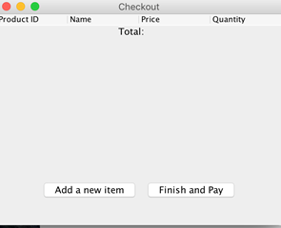

The cashier selects the add a new item button. The input productID screen appears.

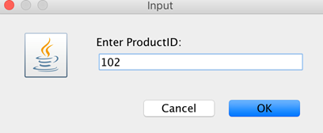

The cashier inputs the productID of the product they want to checkout and selects ok. The input quantity screen appears.

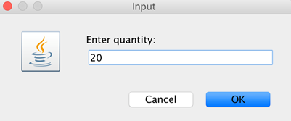

The cashier inputs the quantity of the product they want to check out and selects ok.The checkout screen appears. The cashier repeats these steps until all the products that need to be checked out are done.

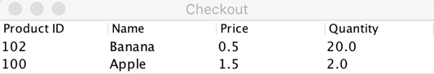

The user selects the checkout button and is returned to the home screen.



**5. As a manager, I want to add a new product to the System’s database**

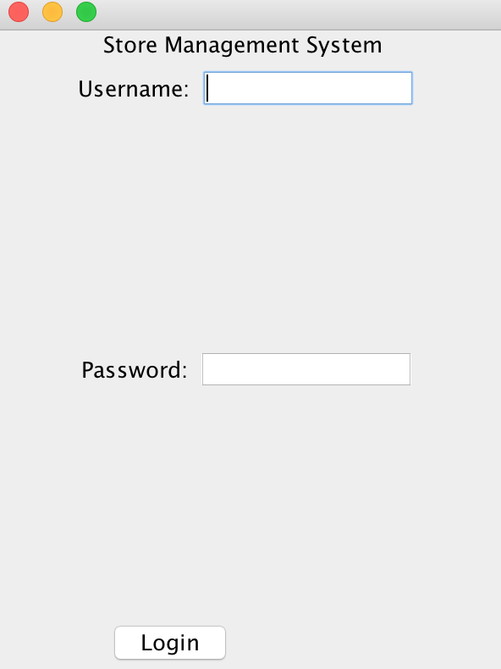

Login to the Store management system using Manager account and password. The Store homepage will be shown next.



Click Manage Product Button. The Product View page will be shown next.

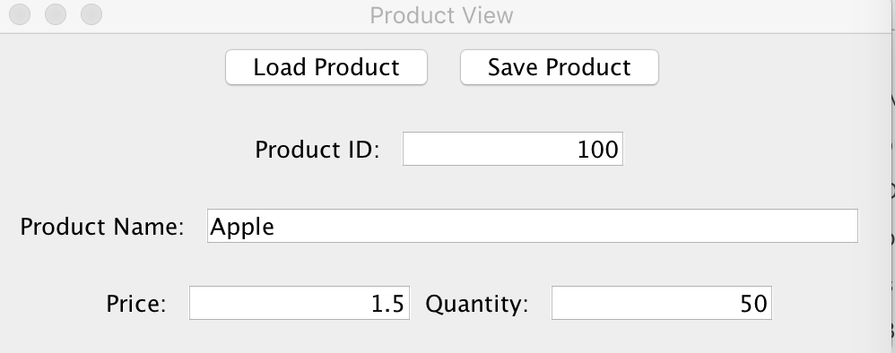

Enter product data and press “Save Product” button to add it in the system.

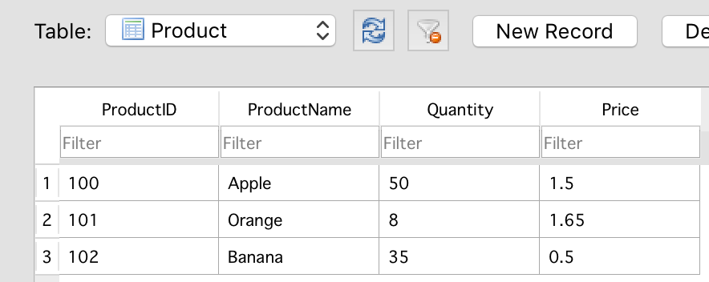

**6. As a manager, I want to update a current product in the system's database**



Login to the Store management system using Manager account and password. The store homepage will be displayed.



Click Manage Product Button. The product view page will be displayed.



Enter product data and press “Save Product” button to update it in the system.

Database before and after Updated Apple quantity:

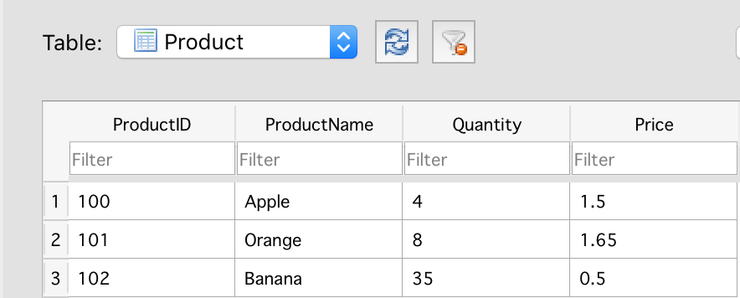



**7. As a manager, I want to create a new user, assign role (e.g. manager or cashier), generate a default password for a new user**



Login to the Store management system using Manager account and password. The Home page will be displayed.



Click ‘Create New User’ Button. The Create New User page will be displayed.

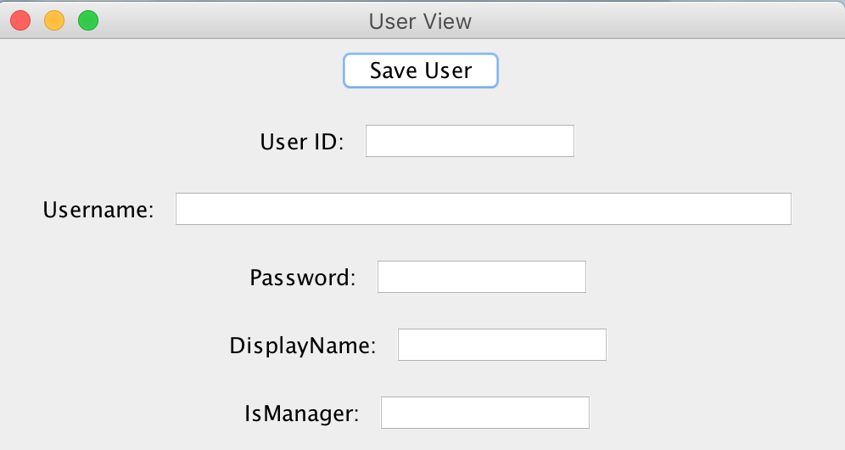

Enter user Data. Default password is shown. Enter ‘True’ in the ‘isManager” text box to add a new Manager to the system. Enter ‘False’ to add a Cashier.

Database before and After adding Leonard Phong.

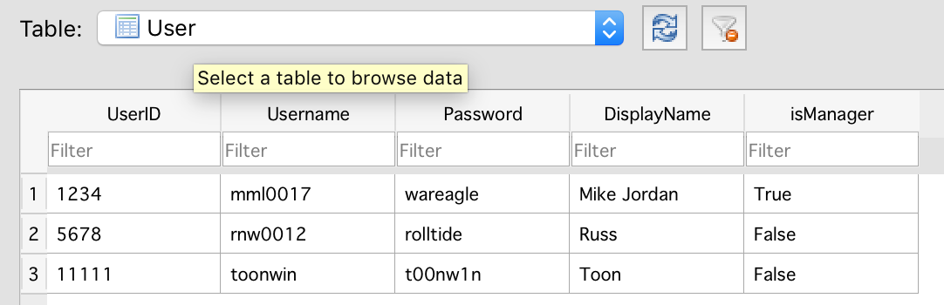



**8. As a manager, I want to view and sort the business report: e.g., what products are sold, how many units, how much revenue…**



Login to the Store management system using Manager account and password. The Store management homepage is shown.



Click ‘View Reports’ Button. Business reports page will be displayed.